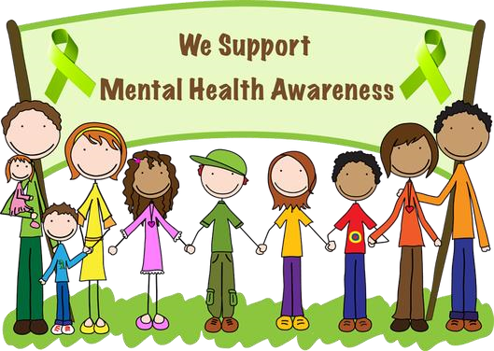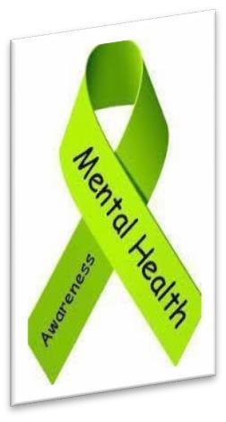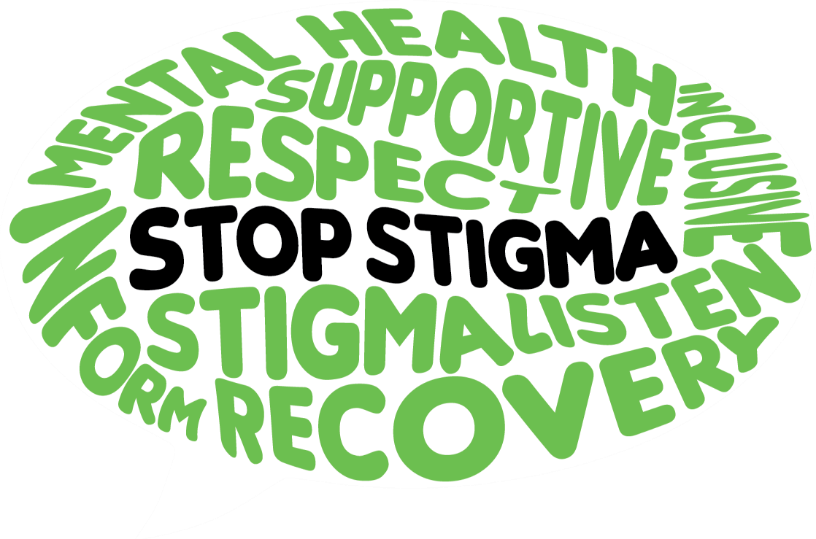

**Join us for a drive through**

**e**

event to increase awareness for

Mental Health and learn about

Available resources. Grab & Go information & treats!

**This event is free**

**to all!!**

**Santee**

**-**

**Wateree Community**

**Mental Health Awareness Day**

**Stronger Than the Stigma**

**Friday,**

**May 14, 2021**

**am**

**11:00**

**–**

**22**

**:00**

**pm**

**Santee**

**-**

**Wateree CMHC**

**801**

**N. Pike West, Sumter, SC 29153**

**803**

**-**

**775**

**-**

**9364**

**Adult Services**

•

**803**

**-**

**775**

**-**

**7898**

**CAF Services**

**Wear Green to show your support**

**!**